
9895 Hidden Hollow Trl
Broadview Heights OH 44147
boos.herrel@gmail.com

These wires are slightly thicker than originals (7mm) and will fit in the tubes with little difficulty. Adding in the engine wires may not fit!
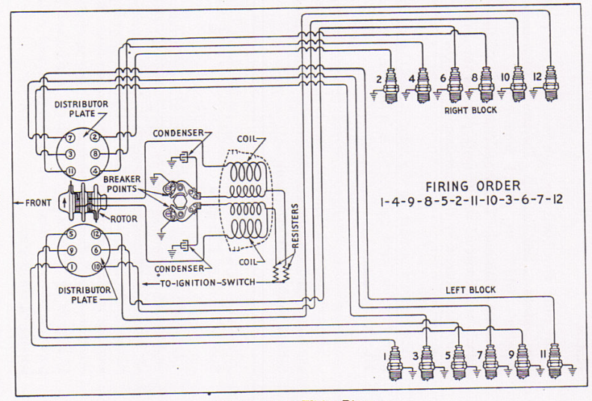

Wiring the spark plug conduit tubes can be a daunting experience but with a little patience and thought, should only take about 45 minutes

Think it through before you begin. Keep in mind this just covers the plug wires. As you may know the engine harness is also supposed to feed through, and on ’42 and up cars the tubes were enlarged to help accommodate the OD wires. My suggestion: use tie wraps to neatly secure the engine wires to the tubes on the underside nice and neat and avoid a lot more frustration. These wires are slightly thicker than originals and will fit in the tubes with little difficulty. Adding in the engine wires may not fit! If you want to install the engine wires, they must be installed first in the LH tube to accommodate the wire end terminals more easily.

First, decide if you need to refinish your tubes and do that a few days in advance so the paint dries well. Some people may advise using the old wires to pull through new ones. Usually that’s a disaster as they are hard and don’t flex well so its best to remove them first.

Use of a pick, hooked end tool or welding rod with a hook can be helpful as well as a strong flashlight to peer into the holes looking for the wire as you feed it through. Feeding from the front end then requires looking for the spark plug end through the holes to pull it out. Feeding through the spark plug hole towards the terminal plate in some instances is easier as it simply must pass out the front hole on that end. Make sure you don’t put the wire in backwards!

First, disconnect all wires and remove the looms/tubes from the engine. Take out the 4 intake bolts that secure them and then determine proper measurements to drill some holes in a board and bolt them to the board, with the fronts overhanging your bench, unless you put feet on the board. You don’t want to clamp it to your bench as you will end up turning the board to the side a few times to look for the wire end through a hole and then using a pick or hooked end tool to snag them to pull them through the holes. Number the board under each respective hole to the wire number accordingly to make things easier to reference. Then, checking the respective terminal plate numbers, you can sort out the left and right wires according to the terminal plate and then feed it through either from the plug end or the terminal plate end as some are easier fed in one direction than the other.

Suggested best practice is to first wire each tube separately, then deal with the cross over wires. For the RH block, you can install wires 8, 4, in from the plug outlet hole and push through to the front/terminal plate end. For the LH block, you can install wires 9, 5, in from the plug outlet hole and push through to the front/terminal plate end. Hold off on 1 & 2 as they simply feed from plug outlet hole down to the front/terminal plate end and since they are both below the cross over intersections, best to leave them out at this point. Then install LH block wires 6, 10, 12 by pushing them through the RH tube cross over hole down to the front/terminal plate end. Then install RH block wires 3, 7, 11 by pushing them through the LH tube cross over hole down to the front/terminal plate end. Then you can feed the plug end crossed over wires up the opposite tubes to their respective outlet holes. Then install wires 1 & 2 through the plug outlet down to the terminal plate. This is confusing, so read it a couple of times as you look at the diagram. Wires should extend out of the plug hole ~7”.

Take note of the terminal plate holes and numbers. The terminal plates are the same left and right and are interchangeable. Which wires plug into what holes is critical. Get one wrong and 2 are wrong. Note there is a small tab on the terminal plate by the 6/8 hole. That tab fits a notch on the distributor housing and therefore can only be installed one way. Installation then enables the numbers to be either right-side up or upside down! You want to plug the wires into the corresponding holes numbered right-side up!! Be sure to pass the wires through the dome cap and rubber boot before you plug them into the plate. Note the tab and notch to align the dome cap to the plate to orient the wires in the dome so it can be positioned more easily with the post poking through the plate and secured by the rubber ring.

Start with the longer wires first as they feed straight through. Once a few wires cross over to the other tube, those cross over intersections become the traffic jam and the more wires the harder it gets. Of course, there will be six wires in that cross over. Use of talcum powder, silicone spray or silicone grease can help too.

Knowing old Henry was an efficiency guru, one must believe there is a method to this that probably only takes 3 minutes!

Once you have them in, you’ll need a continuity meter to find what end corresponds to what plug as you fit them into the corresponding holes of the terminal plate as the numbered tags will inevitably fall off or be hidden in the tube. Install back on the engine with the two halves of the cross over tube.

